|  |  |
| --- | --- |
| **TEAM ID** | **PNT2022TMID44982** |
| **PROJECT NAME** | **Personal Assistance for Seniors Who Are Self-Reliant** |

**Sprint 1**

**The AIM of Sprint 1 is SIMULATION CREATION.**

**Duration : 6 days**

In this Sprint 1 we have found out what the elderly people used to and suffer in Alzheimer disease .So the we had decided that we should find the solution of four different Ideas from our teammates

1. Our teammate DAYANA P,

Medicine Remainder for Alzheimer disease person to keep an instant remainder for their medicine that is taken by them and keep them on track of their medicine taken.

1. Our teammate SWETHA K, Medicine Remainder for elderly person that are elderly person in home and Hospital and keep them check in Medicine that are forgotten by Caretaker and Person around them.
2. Our teammate YUVASHREE S, A Stock Remainder of Medicine for Elderly Person and keep the medicine in check every time if the medicine prolonged for another week and have the refilled alarm for the medicine that need to taken.
3. Our teammate DEVIKA K, VIJAYALAKSHMI V, Scan of medicine to zoom and see the medicine those are taken by the elderly person and keep in check of medication of elderly person. If needed the medication can be upload the App.

By considering all the ideas that are given teammate .We conclude that are of decision made by teammate is make a combine idea of Medicine Remainder App that feature of scanning of medicine , medicine remainder at correct timing, Stock remainder.

What we should complete in sprint 1? The Issue collected from user,

USN 1:As a user, I want to take Medicines on time and monitor my health

USN 2:As a user, I want to take my tablets on time by voice command

USN 3:As a user, I need to take my medicine and I am not able see the dosage of medicine properly

USN 4: As a user, Sometimes my medicine aren’t in stock and I usually forget the Stock of my medication.

REQUIRED MATERIALS:

1. RTC DS3231 module
2. 16x2 LCD Display
3. Buzzer
4. Led(any color)
5. Breadboard
6. Push Buttons
7. 10K Potentiometer
8. 10K,1K Resistors
9. Jumper Wires
10. Arduino Uno Simulation:

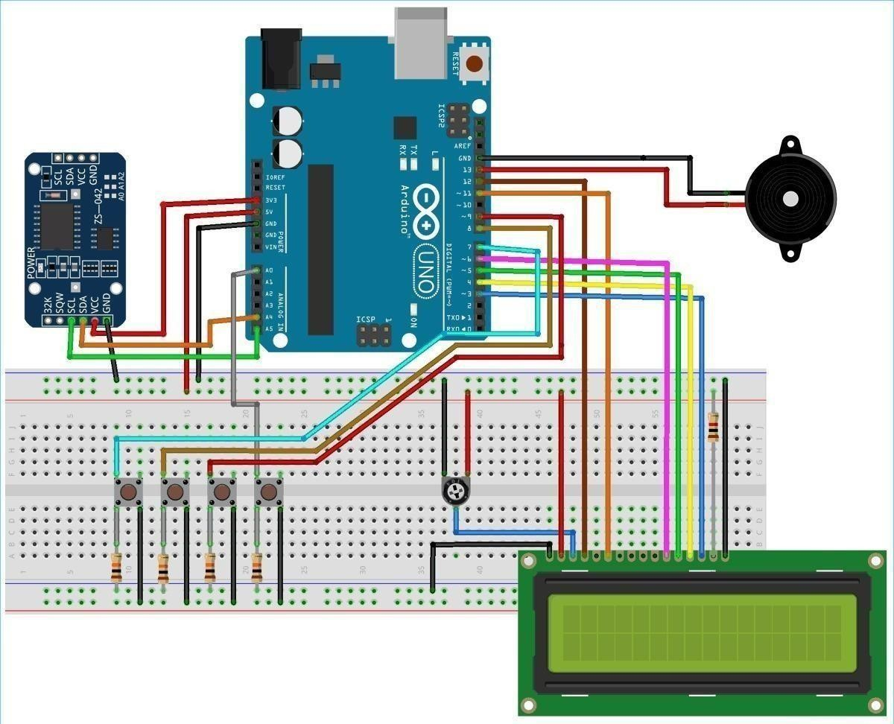

Code:

//Medicine Reminder using Arduino Uno

// Reminds to take medicine at 8am, 2pm, 8pm

|  |  |
| --- | --- |
| /* The circuit:  LCD RS pin to digital pin 12  LCD Enable pin to digital pin 11  LCD D4 pin to digital pin 5  LCD D5 pin to digital pin 4  LCD D6 pin to digital pin 3  LCD D7 pin to digital pin 2  LCD R/W pin to ground  LCD VSS pin to ground  LCD VCC pin to 5V  10K resistor:  ends to +5V and ground wiper to LCD VO pin (pin 3)*/ #include <LiquidCrystal.h>  #include <Wire.h>  #include <RTClib.h>  #include <EEPROM.h> int pushVal = 0; int val; int val2;  int addr = 0;  RTC_DS3231 rtc;  const int rs = 12, en = 11, d4 = 5, d5 = 4, d6 = 3, d7 = 2; pins  LiquidCrystal lcd(rs, en, d4, d5, d6, d7);  #define getWellsoon 0  #define HELP_SCREEN 1  #define TIME_SCREEN 2 | // lcd |



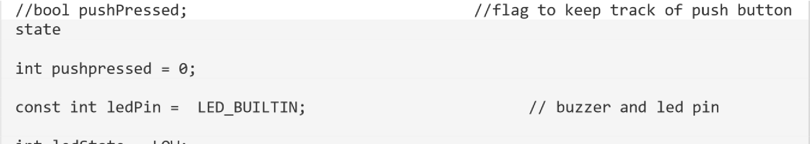



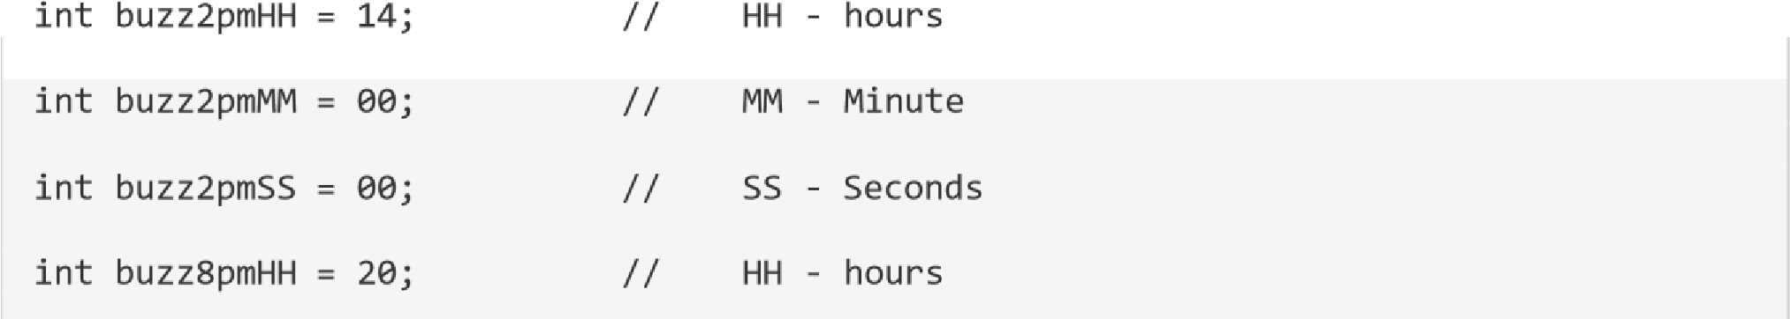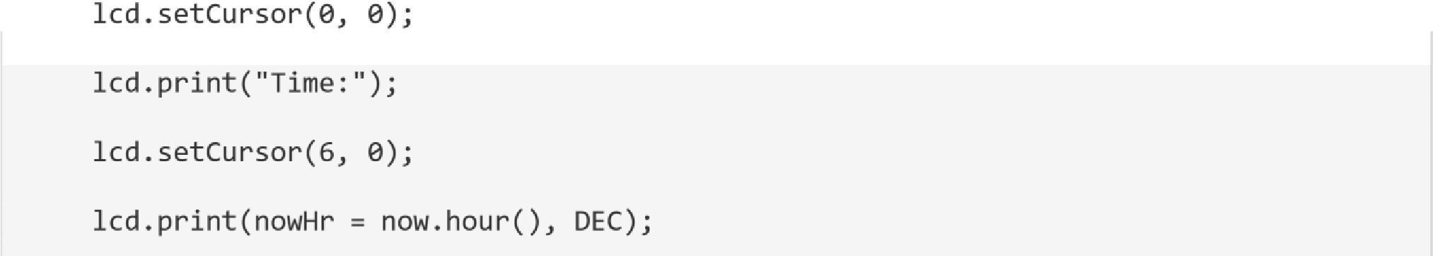

|  |
| --- |
|  |
| rtc.adjust(DateTime(2019, 1, 10, 7, 59, 30)); // manual time set  lcd.begin(16, 2); lcd.clear(); lcd.setCursor(0,  0);  lcd.print("Welcome To"); // print a messege at  startup lcd.setCursor(0, 1); lcd.print("Circuit Digest"); delay(1000);  pinMode(push1pin, INPUT); // define push button pins type pinMode(push2pin, INPUT); pinMode(push3pin,  INPUT); pinMode(stopPin,  INPUT); pinMode(ledPin,  OUTPUT); delay(200);  Serial.println(EEPROM.read(addr));  val2 = EEPROM.read(addr); // read previosuly saved value of  push button to start from where it was left previously switch (val2) { case 1:  Serial.println("Set for 1/day"); push1state = 1; push2state = 0; push3state = 0; pushVal = 1; break; case 2: |

|  |  |
| --- | --- |
| Serial.println("Set for 2/day"); push1state = 0; push2state = 1; push3state = 0; pushVal = 2; break; case 3:  Serial.println("Set for 3/day"); push1state = 0; push2state = 0; push3state = 1; pushVal = 3; break;  }  } void loop() { push1(); | //call to set once/day |
| push2(); | //call to set twice/day |
| push3(); | //call to set thrice/day |
| if (pushVal == 1) { | // if push button 1 pressed |
| then remind at 8am at8am(); | //function to start uzzing at |
| 8am }  else if (pushVal == 2) { then remind at 8am and 8pm at8am(); | // if push button 2 pressed |

|  |
| --- |
|  |
| at8pm(); //function to start uzzing at  8mm  }  else if (pushVal == 3) { // if push button 3 pressed then remind at 8am and 8pm at8am();  at2pm(); //function to start uzzing at  8mm at8pm();  }  currentMillisLCD = millis(); // start millis for LCD screen  switching at defined interval of time  push1state = digitalRead(push1pin); // start reading all push button pins push2state =  digitalRead(push2pin); push3state = digitalRead(push3pin); stopinState  = digitalRead(stopPin);  stopPins(); // call to stop buzzing changeScreen(); // screen cycle function  }  // push buttons  void push1() { // function to set reminder once/day  if (push1state == 1) { push1state = 0; push2state = 0; push3state = 0;  // pushPressed = true; |

|  |
| --- |
|  |
| EEPROM.write(addr, 1);  Serial.print("Push1 Written : "); Serial.println(EEPROM.read(addr)); // for debugging  pushVal = 1; //save the state of push  button-1 lcd.clear(); lcd.setCursor(0, 0);  lcd.print("Reminder set ");  lcd.setCursor(0, 1);  lcd.print("for Once/day !"); delay(1200); lcd.clear();  }  }  void push2() { //function to set reminder twice/day  if (push2state == 1) { push2state = 0; push1state = 0; push3state = 0;  // pushPressed = true; EEPROM.write(addr, 2);  Serial.print("Push2 Written : "); Serial.println(EEPROM.read(addr)); pushVal = 2; lcd.clear(); lcd.setCursor(0, 0); lcd.print("Reminder set "); lcd.setCursor(0, 1); lcd.print("for Twice/day !"); |

|  |
| --- |
|  |
| delay(1200); lcd.clear();  }  }  void push3() { //function to set reminder thrice/day  if (push3state == 1) { push3state = 0; push1state = 0; push2state = 0;  // pushPressed = true; EEPROM.write(addr, 3);  Serial.print("Push3 Written : "); Serial.println(EEPROM.read(addr)); pushVal = 3; lcd.clear(); lcd.setCursor(0, 0); lcd.print("Reminder set "); lcd.setCursor(0, 1); lcd.print("for Thrice/day !"); delay(1200); lcd.clear();  }  }  void stopPins() { //function to stop buzzing when user pushes stop push button if  (stopinState == 1) { // stopinState = 0;  // pushPressed = true; |

|  |
| --- |
|  |
| pushpressed = 1; lcd.clear();  lcd.setCursor(0, 0);  lcd.print("Take Medicine ");  lcd.setCursor(0, 1);  lcd.print("with Warm Water"); delay(1200); lcd.clear();  }  }  void startBuzz() { // function to start buzzing when time reaches  to defined interval  // if (pushPressed == false) { if  (pushpressed == 0) {  Serial.println("pushpressed is false in blink"); unsigned long currentMillis = millis(); if  (currentMillis - previousMillis >= interval) {  previousMillis = currentMillis; // save the last time you blinked the  LED  Serial.println("Start Buzzing"); if (ledState == LOW) { // if the LED is off turn it on and vice-versa:  ledState = HIGH;  } else { ledState  = LOW;  } digitalWrite(ledPin, ledState);  } |

|  |
| --- |
|  |
| } else if (pushpressed == 1)  {  Serial.println("pushpressed is true"); ledState = LOW; digitalWrite(ledPin, ledState);  }  }  void at8am() { // function to start buzzing at 8am  DateTime now = rtc.now(); if  (int(now.hour()) >= buzz8amHH) { if  (int(now.minute()) >= buzz8amMM) { if  (int(now.second()) > buzz8amSS) {  ///////////////////////////////////////////////////// startBuzz();  /////////////////////////////////////////////////////  }  }  }  }  void at2pm() { // function to start buzzing at 2pm  DateTime now = rtc.now(); if  (int(now.hour()) >= buzz2pmHH) { if  (int(now.minute()) >= buzz2pmMM) { if  (int(now.second()) > buzz2pmSS) {  /////////////////////////////////////////////////// startBuzz(); |

|  |
| --- |
|  |
| //////////////////////////////////////////////////  }  }  }  }  void at8pm() { // function to start buzzing at 8pm  DateTime now = rtc.now(); if  (int(now.hour()) >= buzz8pmHH) { if  (int(now.minute()) >= buzz8pmMM) { if  (int(now.second()) > buzz8pmSS) {  ///////////////////////////////////////////////////// startBuzz();  /////////////////////////////////////////////////////  }  }  }  }  //Screen Cycling  void changeScreen() { //function for Screen Cycling  // Start switching screen every defined intervalLCD  if (currentMillisLCD - previousMillisLCD > intervalLCD) // save the last time you changed the display  { previousMillisLCD = currentMillisLCD; screens++; if (screens > maxScreen) { |
| screens = 0; // all screens over -> start from 1st  } isScreenChanged = true;  }  // Start displaying current screen if (isScreenChanged) // only update the screen if the screen is changed.  { isScreenChanged = false; // reset for next iteration switch (screens)  { case getWellsoon:  gwsMessege(); // get well soon message  break; case  HELP_SCREEN:  helpScreen(); // instruction screen  break; case  TIME_SCREEN:  timeScreen(); // to print date and time  break; default: //NOT  SET.  break;  }  }  } |

**CONCLUSION :**

The conclusionof Sprint 1 we have analyst all the problems that are faced by the elderly people and created the dry code simulation that are given by ideas by our teammates.